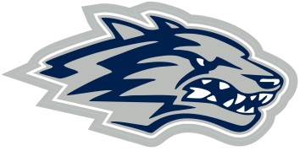
Support Eagle River High School Wolves Football
With a 2022-2023 Corporate Booster Sponsorship

The Eagle River High School football program needs your support! Our Booster Club is aiming to expand our young program, including purchasing uniforms and state-of-the-art helmets, and improving safety and training gear. Other expenditures include expensive travel to compete against in-conference opponents, developing a varsity locker room, and continuing to grow our home stadium.

Please consider the options below and decide how your business can help our athletes, students, and community. Sponsorships are valid from June 1st, 2022 to May 31st, 2023.

Business/Organization Name: Contact Person:
Address:
Web Address:
Phone: Email:

Become a Corporate Booster Sponsor (Please indicate chosen package; packages are comprehensive, and include all benefits of lower sponsor levels):
Sponsor Levels | Benefits Package
$1000  CHAMPIONSHIP  Greatest value with maximum exposure | - 4’ x 8’ Company Banner to be displayed yearlong at the ERHS Football Stadium (the banner will be removed during winter months for storage)  - 3’ x 5’ Banner to be displayed yearlong in the ERHS gymnasium for all indoor sporting events.
$500  TOUCHDOWN | - 4’ x 8’ Company Banner to be displayed yearlong at the ERHS Football Stadium (the banner will be removed during winter months for storage)
$250  1st and GOAL | - Season-long advertisement on ERHS Football Stadium concession stand  - Full color advertisement in home game programs  - Recognition from announcer during home games

Return this form & sponsorship payable to:
ERHS Football Booster Club, PO Box 770608, Eagle River, AK 99577
You will be contacted via email to approve your banner proof.

Questions? Please contact Melanie Malone at (907) 350-5463 or wolvesfootballboosters@gmail.com.

Thank you for supporting the
ERHS Wolves Football Program

